**MINI PROJECT**

**GAS LEAKAGE DETECTOR**

**AIM:**  
To design a project on gas leakage system by using Arduino UNO.

**APPARATUS:**

**Software Required:**

* Arduio UNO
* C Language

**Hardware Required:**

* Arduino Uno
* MCU display
* Gas sensor module
* Buzzer
* 16*2 LCD display
* Resistor
* Cooling fan
* Connecting wires
* Relay

**Procedure:**

1. Connect Uno board with programming cable and connect USB side to computer.
2. Open Arduino IDE and Copy paste the above code.
3. Before clicking on upload check if proper board is selected.
4. You can click on tools then Board option later select Arduino Uno.
5. Now cross check for port number and you can select this from tools and port.
6. Once you are done with this you can hit on that upload button.
7. Once you have finished uploading successfully disconnect USB cable.
8. Now you can power Arduino Uno using external battery.
9. We are using 3.7v battery we did not use any resistor, if you are using higher volt battery you may need resistor as per the voltage values.

**Circuit diagram:**

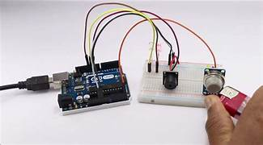

**Source Code:**

**void setup()**

**{**

**pinMode(5,OUTPUT );**

**pinMode(2, INPUT);**

**}**

**void loop()**

**{**

**if( digitalRead(2)==LOW)**

**{**

**digitalWrite(5, HIGH);**

**delay(1000);**

**}**

**else**

**{**

**digitalWrite(5, LOW);**

**}**

**}**

**Output:**

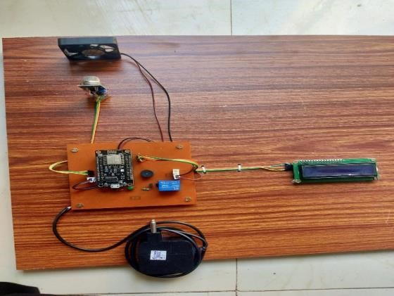

**Result:**Hence, we have successfully completed and executed the project of gas leakage detector using Ardunio-Uno”.